Setting up Gradebook in eLearn – Step by Step
Course Gradebook settings
- Open up the Gradebook from the Grades button in the lefthand column of your course page.
- Choose the Setup tab.
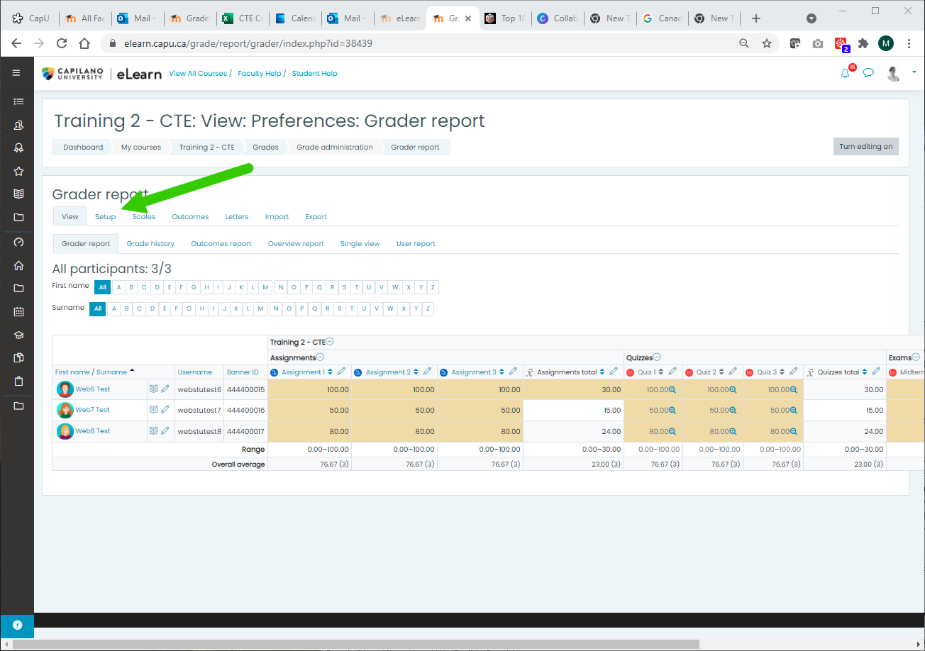

Add Categories
- At the bottom of the Gradebook page you’ll see a button for Add category.
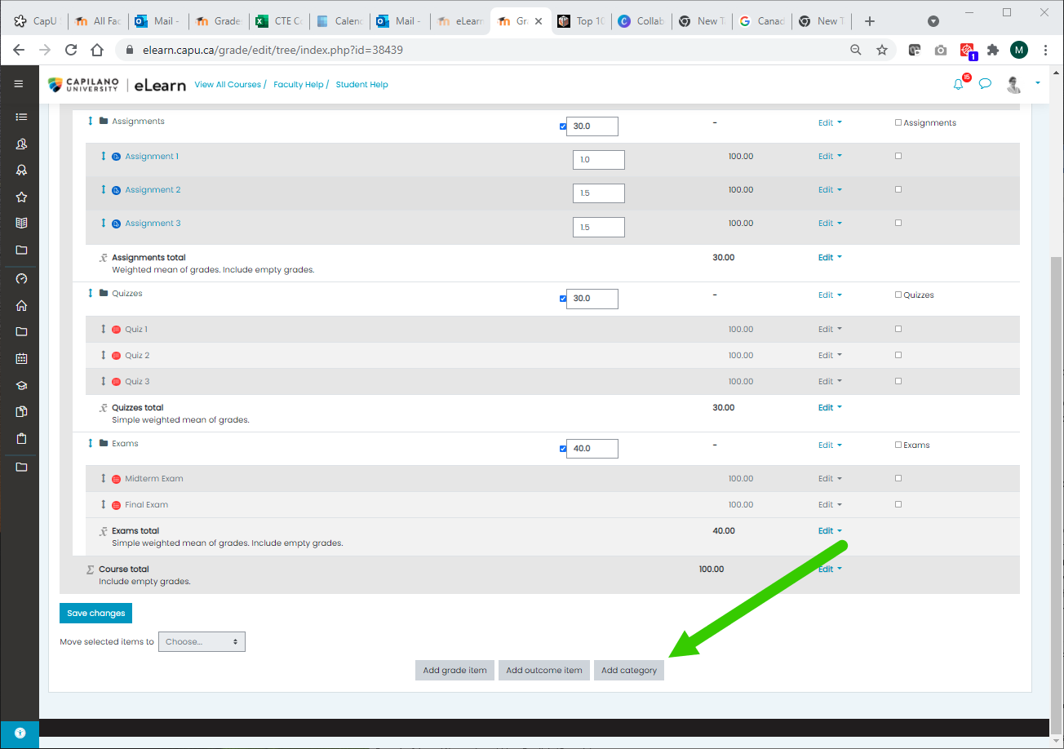
- Use it to add categories for each of your assessment categories (e.g., Assignments, Case Studies, Final Assignments).
- For each category, choose Simple Weighted Mean of Grades as the aggregation method. Make sure that the value of each item in the category is appropriate to its weight. For example, if you have one item with a maximum grade of 100 and one with a maximum grade of 50, the second item will be worth half as much toward the grade for that category.
- Under Category total, make sure that the Maximum grade for each category is equal to the weight for that category (e.g., for the Assignments category both the weight and the maximum grade should be 40)

Change the Gradebook aggregation method to Natural
- Click on the Edit tab at the top right next across from the black folder with the course name.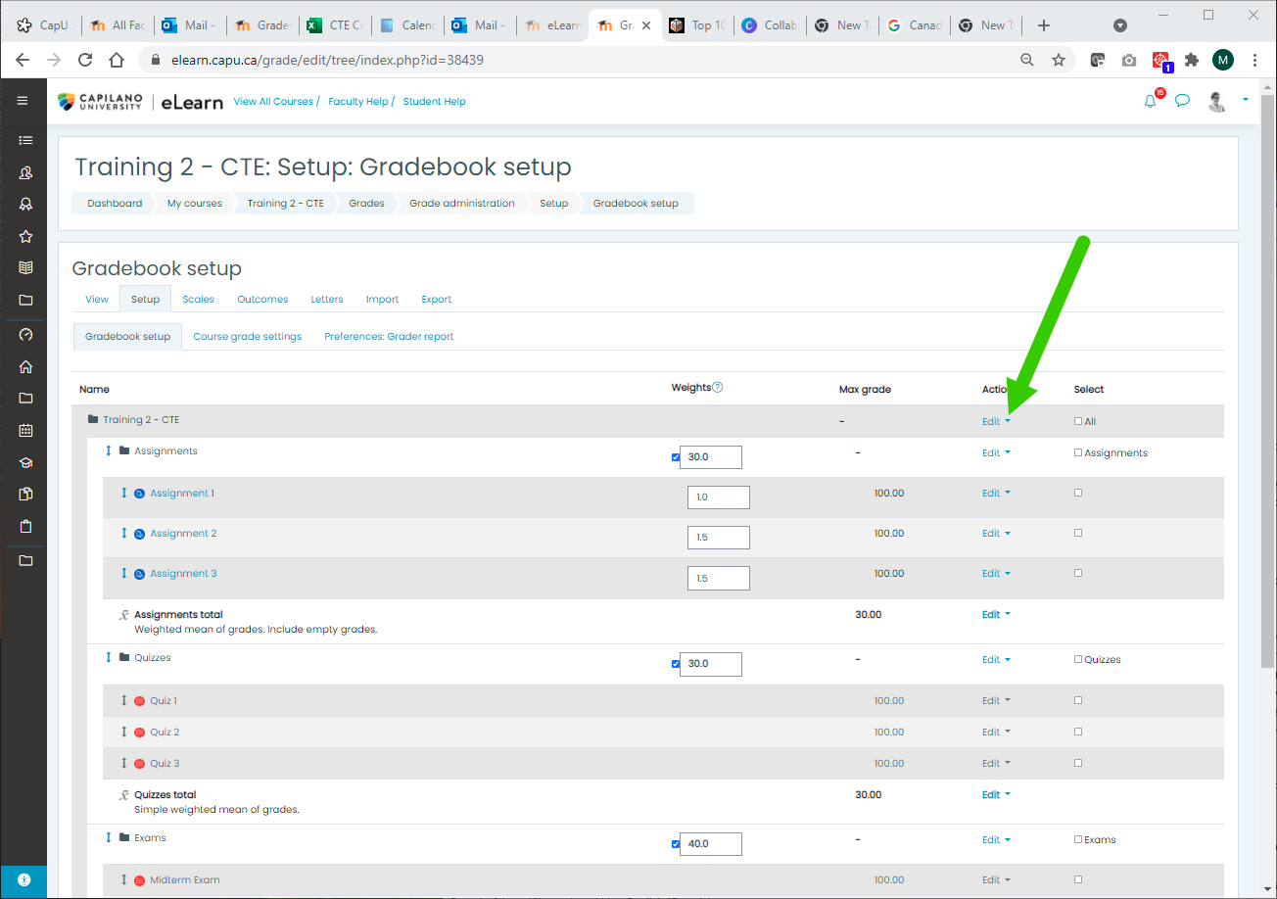
- Under Edit Settings choose Natural as your Aggregation method for the entire Course Gradebook.
- In the Gradebook Setup view, assign weights to each category proportional to their contributions to the final mark (e.g., Assignments: 40, Case Study: 30, Final Exam: 20)
Add Assignments/Quizzes
- Add your assignments to the course, using the Add activity or resource link at the bottom of your module/section.
- Under the settings for the assignment, look in the Grades section and change Grade category to the category that you’ve created for it (default is Uncategorized).
Check the Math
- Go back to Gradebook/Setup and check that the learning activities are in the appropriate categories and that the weighting of each category adds up to 100.
- Enrol a colleague as a fake student and assign full marks for every assignment. If their final mark doesn’t add up to 100, then you need to go back and check your settings.

